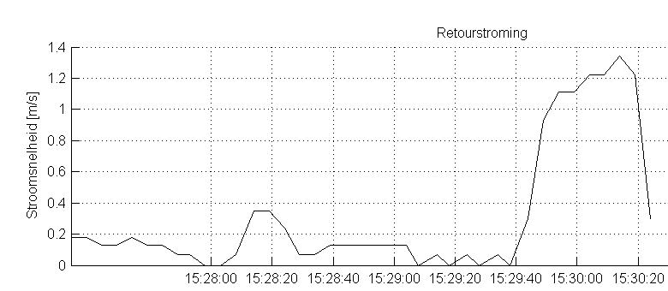
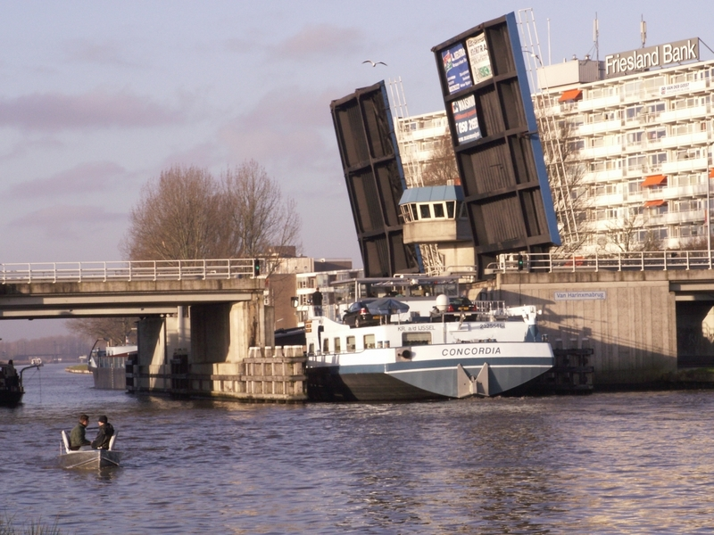
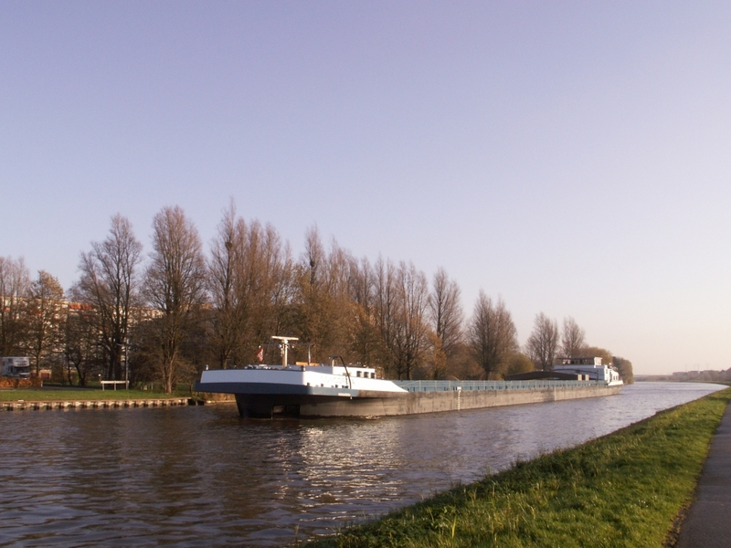
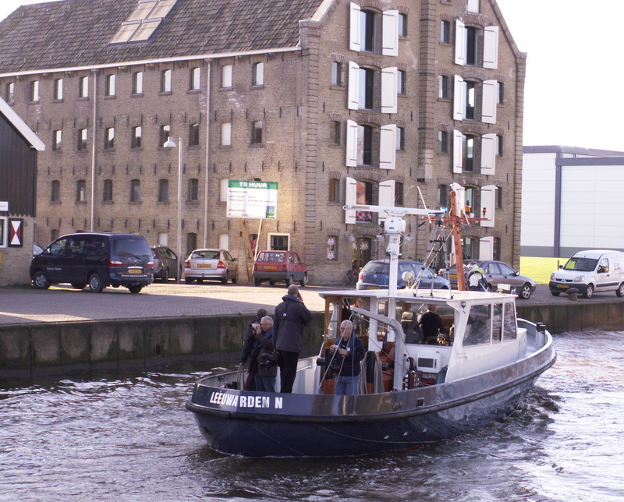
Ship induced flow [m/s]

Measurement of ship induced flow in the Van Harinxma channel, the Netherlands

Vrije ruimte (niet gebruiken)

Svašek Hydraulics
Schiehaven 13G, P.O. Box 91, 3000 AB Rotterdam, The Netherlands.
Phone +31 10 467 13 61, Fax +31 10 467 45 59, Internet: www.svasek.com, E-mail: info@svasek.com

SV1416
The province of Fryslân (located in the north of the Netherlands) is investigating the need to upgrade the Van Harinxma channel from a class 4 to a class 5 inland waterway. The Van Harinxma channel is 37.5 km long and is located between Harlingen and Leeuwarden. It was completed in 1951 and is currently navigable for ships up to 85m long (class 4).

A test voyage with a class 5 ship called “Concordia” along the channel was carried out. The ships dimensions are 110m long and 11.5m wide. During this voyage around 30 measurements of the ship induced flow and the water level change were performed from an accompanying vessel. The equipment used was a Valeport Impeller Current Meter to measure the ship induced flow (see graph above) and a Diver Pressure Gauge to measure water level change.

The results were used to identify possible erosion of the channel banks and to identify possible bottlenecks.

Client
Province of Fryslân / Grontmij

Location
Van Harinxma channel, the Netherlands

Date
2006

Services
Measurements of ship induced flow

